FORM 29

Regulation 4(1)

THE CLINICAL TRIAL APPLICATION FORM

(The application form shall be completed in full, each part is to be cross-referenced to the detail in the clinical trial protocol, the investigator’s brochure, and the other documents attached the application)

Part 1: Identification of the clinical trial

- Title of the clinical trial

- Number of the clinical trial protocol, its number, date and version

- Contact person and contact details

- [NDA reference number]

- Declaration of intent signed by the principal investigator

We, the undersigned have submitted all the required documentation and have disclosed all the information required for approval of this application.

We have read the clinical trial protocol and the investigator’s brochure which are submitted with this application.

We have the authority and responsibility to oversee this clinical trial, and agree to ensure that the trial will be conducted according to the clinical trial protocol and the laws of Uganda.

Applicant (Local contact): Name: Date:

Signature:

Designation

Principal investigator: Name: Date:

Signature:

Designation

Part 2: Basic administrative data on the application

Name and address of the registered office of the applicant


Name: | Telephone | Fax | E-mail | Physical | Postal
Name: | number(s): | Fax | address | address | address

Applicant

Sponsor (if any)

Manufacturer

Part 3: Drugs to be used in the clinical trial

- Investigational drug

  - Identifier or name of investigational drug (code if applicable)

  - Registration number

  - Manufacturer(s) (include all sites)

  - Active ingredient, complete composition, potency and presentation

  - See Attachment 4 for details of the required information.

  - Release specifications and tests. (include certificate of analysis).

  - Current approved package insert if available.

- Comparator, concomitant and rescue medications (and placebo)

  - Proprietary name and INN

  - Active ingredient(s), composition, and presentation

  - Registration number(s) (country)

  - Approved package inserts to be appended to application [Appendix 6]

- Details of handling clinical trial drugs

  - Shipping, delivery and distribution of trial drugs

  - Details of storage requirements and arrangements for cold-chain maintenance where necessary and monitoring during distribution.

  - Details of dispensing trial drugs and waste disposal procedures.

  - Packaging and labelling of the medical products

  - Estimates of quantities of each medication (presentation) to be used for the trial, and for which an import permit is needed.

1152

Part 4: Sites and investigators

- Principal investigator
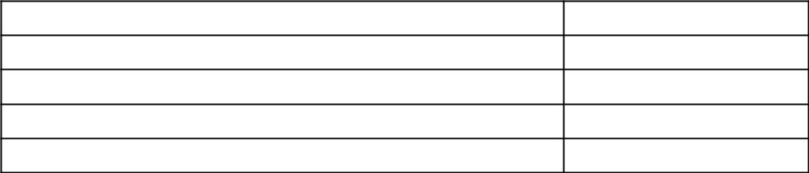

Name:

Qualification

Contact details

Physical address

Declaration of capacity and interests [Appendix 10]

2. For each clinical trial site indicate the following -
  - Site identifier (Name)

  - Physical address: (for rural sites include GPS coordinates)

  - Telephone and fax numbers

  - E-mail address

- Description of the site facilities and staff -

  - Clinic and counselling rooms

  - Emergency facilities

  - Facilities for special examinations (if required)

  - Capacity to collect, prepare, store and transport clinical samples

  - Storage and handling facilities for drugs

  - Name and qualifications of person with responsibility for dispensing drugs

- Site principal investigator
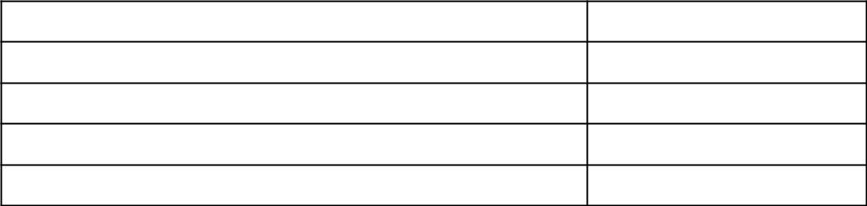

Name:

Qualifications

Contact details

Physical address

Declaration of capacity and interests [Appendix 10]

- Site investigators and trial-specific support staff

Name: Qualifications Contact details Physical address

Declaration of capacity and interests [Appendix 10]
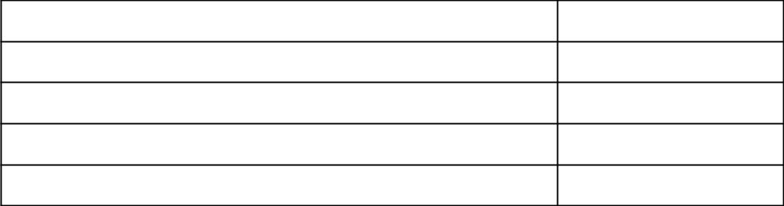

- For a clinical site that is a hospital or public health clinic indicate -

  - The responsible administrator

  - The Contact details

  - Append signed letter of agreement for clinical trial to take place.

- Append signed agreement between the principal investigator and the sponsor. (Appendix 13)

Part 5: Subjects

- Numbers of subjects as stipulated in the table below

  - Total number to be enrolled worldwide

  - Total number to be enrolled in Uganda

  - Number of trial sites in Uganda
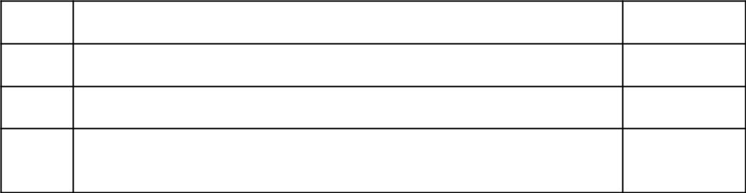

Intended numbers of participants at each site - evidence
(d)
of availability

- Duration of the clinical trial

- Estimated duration of the clinical trial: From first enrolment to final report

- Duration for individual subject

  - Screening period

  - Intervention period

  - Follow-up period

- What is the intended compensation for time and other inconvenience per subject? (This is not compensation in terms of damage).

Part 6: History of previous clinical trials and clinical trials in progress

- List the titles of previous trials with this (or similar) drugs in Uganda

- List the titles of previous trials with this (or similar) drugs in other countries

- Append interim or final report of the clinical trials. (This may be in the investigator’s brochure or APPENDIX 3)

- Include a letter or certificate from the regulatory authorities in countries where previous trials have been undertaken (including those in-progress) that these trials satisfactory.

Part 7: Ethics review

- Provide approval for clinical trial protocol for each site [Appendix 11]

- What GCP Guidelines have been followed in compiling this protocol?

- Will GCP training be provided for local staff and investigators?

Part 8: Monitoring and reporting of clinical trials

- Describe the safety and monitoring plan for each site.

- Describe the system to be used to detect, record, assign causality and the actions for adverse events.

- Describe the actions to be taken following reports of serious adverse events.

- Describe the composition and remit of the data safety monitoring board or similar body. Include conditions for pause- or stop- rules.

- When are interim reports to be submitted?

- Estimated due date of final report

Part 9: Insurance

- Provide a copy of the current insurance certificate. (Schedule 9)

- Provide evidence that each member of the clinical trial team is covered for the relevant malpractice insurance for this trial.

Part 10: Description of the clinical trial

- Is the title of the clinical trial fully descriptive?

- Summarized rationale for the clinical trial, including relevance to Uganda

- Brief background information should include:

  - The disease or condition and local epidemiology

  - Properties of the drug - hypothesis for action

  - Description of risks of the protocol and the potential harms of the drug.

  - Pre-clinical animal toxicology test results in-animals and in-vitro that establishes probable safety and efficacy in humans (this should be cross referenced to the details in the Investigator’s brochure)

  - Prior clinical trial report summaries that establishes probable safety and efficacy in humans (this should be cross referenced to the details in the Investigator’s brochure)

  - Include evidence that the formulations used in the pre-clinical and previous studies are identical to that in this application. Any variations should be highlighted and justified. (this should be cross referenced to the details in the Investigator’s brochure)

  - Published reviews or reports relevant to this disease and this type of drug.

- Objectives of this clinical trial (List as primary and secondary objectives and provide justification)

5.1 Trial design: describe and justify each component by -

- Phase

- Placebo or comparator

- Randomization and blinding

- Other detail

5.2 Time sequence –

(Insert a table of screening, intervention and follow-up visits).

5.3 Participants

- Eligibility

- Inclusion criteria - list and justify each

- Exclusion criteria - list and justify each

5.4 Treatment regimens for each group.

(The table in 5(2) may be used to set this out)

5.5 Follow-up, sampling collection and monitoring plans:

  - Immediate monitoring - intermediate monitoring - long term monitoring

  - Diary cards

  - Telephone access to investigators

- Outcomes measurements and analysis

- Describe each outcome or variable (including safety) and explain or justify.

- Describe the samples that will be collected and the analyses to be conducted on each sample.

- Provide evidence that the laboratories that will conduct the safety screening and the end-point assays are accredited and competent to do the assays. (Appendix 8)

1156

  - Describe the intended statistical analysis to be conducted. Provide evidence that the clinical trial is powered to provide the intended outcome.

- Are any sub-studies intended? Provide full details.

- Are any genetic studies (HLA-typing or gene marker analysis) intended? Provide full details, and justify this. Is there a separate consent form for this?

- Will clinical samples be stored for any period beyond the duration of this trial?

  - What is the purpose of such archiving?

  - What controls are to be placed on their confidentiality and possible future use?

- Participant information leaflet and consent form

  - Append a copy of the participant information leaflet and consent form [Appendix 4]

  - In what languages will this be available?

  - For the subjects who are minors, append the consent form of the parents or guardians of the minors.

  - Are there separate consent form for sub-studies or genetic studies?

Part 11: Publication Policy

Provide details of the investigators and sponsors intentions and freedom to publish the outcomes of this clinical trial.

1157

FORM 30

Regulation 4 (3)

LETTER OF AUTHORIZATION FROM HOLDER OF PATENT OF DRUG, LICENCED PERSON OR MANUFACTURER OF DRUG

Date: ……………………………………….

Company name …a company operating under the laws of ………. located at:

Physical address ………………………………………………………………..

Tel No: ………………………………………………………………………….

Fax No: …………………………………………………………………………

E-mail address:………………………………………………………………….

Company in Uganda

Name …………………………………………………………………………..

Physical address ………………………………………………………………..

Tel No: ………………………………………………………………………….

Fax No: …………………………………………………………………………

E-mail address:………………………………………………………………….

To represent us in Uganda for the application authorization to conduct a clinical trial for

Protocol No: _________________________________

Release date: ________________________________

…………………………………………………... (name and address of local

company) is authorized to be the agent of the holder of the patent of the drug or licensed person or manufacturer of the drug in the clinical trial and is to be responsible for all matters pertaining to the clinical Trial certificate.

………………………………………

Authorised name and signature

1158

FORM 31

Regulation 4 (4) (d)

DECLARATION BY PRINCIPAL INVESTIGATOR

Clinical trial protocol number..............……………………...............................

Name:

Role in clinical trial

Title of clinical trial:...................…………….........

Clinical trial site:......................………………........

(Please attach Curriculum vitae).

- I am aware of the responsibilities of my role as……………….in clinical trial, number……………as required by the Laws of Uganda.

- I have read and understand the attached clinical trial protocol, investigator’s brochure and supporting documentation and I will comply with the procedures and requirements included in them.

- I have read the attached clinical trial application form as submitted to the Authority and confirm that the information is complete, true and accurate, and conform to the clinical trial protocol and supporting documentation.

- I will not commence with this clinical trial before a clinical trial certificate is issued by the Authority. I will provide the Authority and any other relevant authority, with reports as may be required.

- I will obtain the consent of the subjects, or if they are not legally competent, from their legal representatives, parents or guardians.

- I will ensure that every subject (and other person involved in the clinical trial including the relatives of the subjects) is treated in a dignified manner and with respect.

7. I DECLARE: I have or have (delete as applicable) no conflict of interest in terms of financial interests or personal relationships that may inappropriately influence my responsibilities and conduct of this trial.

Initials: ………………………………………………………………

1159

8. I DECLARE: I have not previously been associated with any clinical trial that has been terminated, or a clinical trial site that was closed, due to failure to comply with internationally accepted Good Clinical Practice Guidelines adopted by the Authority.

Initials: …………………………………………………………………

- I have received suitable, recent training in internationally accepted Good Clinical Practice Guidelines adopted by the Authority.

Signed …………………………… Date …………………………

Witness …………………Name…………………………Date ………………

1160

FORM 32

Regulations 4 (4) (e)and 15 (3)

DECLARATION BY MONITOR

Name:…………………………………………………………………………...

Title of the clinical trial:

Number of the clinical trial protocol:

Clinical trial site:

I, the undersigned, declare that:

- I am familiar with the internationally recognized and national guidelines of internationally accepted Good Clinical Practices Guidelines adopted by the Authority and understand the responsibilities and obligations of the clinical trial monitor within the context of this trial.

- I have notified the Authority of any aspects of the above with which I do not or which I am unable to, comply. (If applicable, this may be attached to this declaration.)

- I will carry out my responsibilities as specified in the trial protocol and in accordance with requirements by the Authority on internationally accepted Good Clinical Practices Guidelines adopted by the Authority.

- I declare that I have no financial or personal relationship(s) which may inappropriately influence me in monitoring this clinical trial.

- I have* or have not (delete as applicable) previously been the monitor at a site which has been closed due to failure to comply with internationally accepted Good Clinical Practices Guidelines adopted by the Authority. (*Attach details.).

- I have*or have not (delete as applicable) previously been involved in a clinical trial which has been closed as a result of unethical practices. (*Attach details).

- I will submit all required reports when needed.

Signed …………………………………… Date …………………………

Witness ………………………………………Date…………………………

1161

FORM 33

Regulation 4 (4) (f)

DECLARATION BY SPONSOR AND PRINCIPAL INVESTIGATOR OF FUNDS OF THE CLINICAL TRIAL

Title of the clinical trial:

Number of the clinical trial protocol:

I, …………………………………………………………………….. (Sponsor)

and

I, ………………………………………………………, (principal investigator)

hereby declare that the funds available for the clinical trial are sufficient for the clinical trial.

Signed Date

SPONSOR

Name

Address

Contact details

Signed Date

PRINCIPAL INVESTIGATOR

Name

Address

Contact details

1162

FORM 34

Regulation 4 (4) (i)

PHAMACEUTICAL DATA ON DOSAGE FORM.

PRODUCT: REF:

(Supporting documents should be appropriately numbered and referenced).

- FINISHED PRODUCT

  - Description (physical characteristics):

  - Composition (complete formula)

  - Active ingredient

Active ingredient: |  | Content

- Other ingredients (adjuncts, exicipents, preservative, colour, flavour, etc):

 | Name of other ingredients |  | Content

- Packing or pack size (brief):

- MANUFACTURE OF PRODUCT

(Enclose the product in an envelope marked ‘CONFIDENTIAL’, if desired.

If so indicate here, with appropriate reference).

- Complete batch manufacturing master formula:

 | Name of ingredients (active and otherwise) |  | Quantities used per batch

- Manufacturing process:

(Provide a brief description and the principles of the process).

1163

3. QUALITY CONTROL

- State whether quality control is done in part or solely by the quality control department of the manufacturer or in an external laboratory.

- If quality control tests are done by an external laboratory, indicate :

  - The name and address of the laboratory;

  - The tests done by the external laboratory;

  - Why the tests are not done by the manufacturer.

- Specifications for the active and other ingredients

 |  | Source (state whether | Manufacturer and
Name of ingredient | Specifications | B.P or U.S.P or | Manufacturer and
Name of ingredient | Specifications | B.P or U.S.P or | country of origin
 |  | manufacturer’s) | country of origin

- In- process quality control:

Tests performed during manufacturing process and sampling protocols:

Tests | Stage at which test is | Frequency of | Quality of sample
Tests | done | sampling | taken each time

- Finished product quality control:
Tests and specification limits (check and release specifications):

Test | Acceptance limits | Release for test method and Limits (B.P. or
Test | Acceptance limits | U.S. Pormanufacturers)

The certificate of analysis to be certified by quality assurance manager.

Certificate of analysis of recent batch of product (minimum 1 batch) enclosed: [ ]

- STABILITY OF PRODUCT:

  - Storage condition must be included on the label.

  - Proposed shelf life of product:

(Where the extension of the shelf life for a clinical trial material is required, the manufacturer shall provide data to support the extension and data in the form of retest results shall be considered).

1164

- STABILITY STUDIES

- Completed stability studies or accelerated stability studies.

(provide a summary of the stability studies, characteristics and degradation products monitoring results and conclusions of completed stability studies). Results of studies of at least one batch are required.

- On-going or proposed stability studies.

(Outline of on-going or proposed stability studies).

- CONTAINERS AND PACKAGING

  - Description of the immediate (primary) containers or packaging:

    - Type

    - Material

    - Capacity, where applicable

    - Closure and liner (type and material), where applicable.

- Description of outer container or packaging

- Dose-measuring device, applicators and administration set, if any:

  - Descriptionortype

  - Material

  - Capacity, where applicable

- Packaging inclusions (such as desiccant and fillers) if any: Description and compositions

- Is there any known interaction between the product and packaging material? (Yes or No); if yes, specify.

- LABELLING (Refer to Attachment 3).

Enclose samples or proposed drafts of the following:

  - Label for immediate package or container of product

  - Label for outer package or container of product

  - Original package insert for comparator drug

1165

FORM 35

Regulation 6 (6)

CLINICAL TRIAL CERTIFICATE

Clinical trial certificate number ……………………………….. issued under

section 40 of the Act by the Authority.

Name of sponsor..………………………………………………………………

Physical address………….Telephone number …………Fax number…………

E-mail address ……………….……….………………………………………..

Title of clinical trial protocol:…………………………………………………

Number of clinical trial protocol:………………………………………………

Date of approval:……………………………Date of expiry:…………………

Name and address of principal investigator……………………………………

Investigational drug product………………………………………………….

Clinical trial site …………………………………………………………….

The conditions of this clinical trial certificate - _______________________________________________________________

………………………………… ……..…………………………

EXECUTIVE SECRETARY DATE

1166

FORM 36

Regulation 10 (2)

APPLICATION FOR DEVIATION FROM CLINICAL

TRIAL CERTIFICATE

Title of the clinical trial:

Number of the clinical trial protocol:

Date:

- APPLICANT

- Name

- Address

- Telephone

- Fax number

- PARTICULARS OF CLINICAL TRIAL (original application)

- Clinical trial number:

- Date of approval of original protocol:

- Principal investigator approved for the clinical trial:

- Number of sites approved for the clinical trial:

- Number of subjects approved for the clinical trial:

- AMENDMENT PARTICULARS

- Does the applicant wish to increase the number of subjects participating

in the clinical trial? Yes ρ
No ρ

- Does the applicant wish to change the dose or regimen of the
investigational medicinal product?
ρ

Yes _{ρ} No

1167

- Does this amendment request require a new consent form to be signed
by the participant?
ρ

Yes _{ρ} No

If “Yes” please submit new PIL together with this application.

- Does this amendment request require a new consent form to be signed
by the participant?
ρ

Yes _{ρ} No

If “Yes” please submit new PIL together with this application.

1. Clinical trial protocol amendment number:

2. Number and date of amendment (for each document submitted):

3. General motivation for the proposed amendment: [List all of the issues included in the amendment and provide the rationale for each amendment]

4. Details of the proposed amendment: [For each amendment, provide reasons for amendment and clearly highlight changes to the original protocol; this can be done either as “old text” replaced with “new text” or with the old text deleted with a line through it and the new text in bold and underlined]

4. Will this amendment apply to all approved site(s)?
ρ
Yes _{ρ}
No

If No: Specify the sites for which the amendment will apply:

- APPROVAL BY THE UGANDA NATIONAL COUNCIL OF SCIENCE AND TECHNOLOGY

  - Date of application to the Uganda National Council of Science and Technology:

1168

- Date of approval by the Uganda National Council of Science and Technology:

I or we, the undersigned, agree to conduct the clinical trial under any conditions that may be granted by the Authority.

_____________________________________ ___________

Applicant (Sponsor or principal investigator) Date

1169

Regulation 10 (3)

FORM 37

APPLICATION FOR ADDITIONAL INVESTIGATORS, CHANGE OF INVESTIGATOR OR ADDITIONAL CLINICAL TRIAL SITES

APPLICATION FOR APPROVAL OF:

- CHANGES IN INVESTIGATOR(S) AT APPROVED SITE (includes additional investigators)

  - ADDITIONAL SITE(S)

    - Title of the clinical trial:

    - Number of the clinical trial protocol:

    - Date:

- APPLICANT

  - Name

  - Address

  - Telephone

  - Fax number

- TRIAL PARTICULARS (original application)

  - Trial approval number:

  - Date of approval of original protocol:

  - Principal investigator approved for this clinical trial:

  - Number of sites approved for this clinical trial:

  - Number of subjects approved for this clinical trial:

1170

- DETAILS OF INVESTIGATOR

1. Name and address of additional investigator or change to investigators: [Proof of ICH - GCP training must be provided for investigators who have not previously participated in clinical trials]

2. Summaries other ongoing or planned studies at the site involving the investigator: [Provide details of studies, including numbers of participants of the clinical trial, whether the investigator is involved in research in a full-time or part-time capacity, and any other details that may affect the capacity of the site at any one time]

3. Date of application to Uganda National Council for Science and Technology

4. Date of approval by Uganda National Council of Science and Technology

5. Is CV for additional investigator(s) attached?
ρ
Yes
_{ρ}
- Is the_{ρ}declaration of intent attached? Yes ρ

No

(If yes, attach declaration)

- CAPACITY OF THE SITE

Describe how the site is structured so as to be able to take on the work for which this application is being made: [Give details of support staff, facilities, back up and any other relevant infrastructure].

- RATIONALE FOR APPLICATION

1.Briefly explain the reason for the new investigator or site:

I or we, the undersigned, agree to conduct or manage the above-mentioned trial under the conditions as stated in this application. (The person(s) undertaking legal responsibility should sign this form).

____________________________________ _________________

Applicant (Sponsor or principal investigator) Date

1171

Form 38

Regulation 17

LABELLING INVESTIGATIONAL DRUG PRODUCTS FOR CLINICAL TRIAL

The following information shall be labelled on the carton, inner label and the blisters or strips of the investigational drug product for a clinical trial:

 | Unit carton | Inner | Blister or
Parameters | or subject | Inner | Blister or
Parameters | or subject | Labels | Strips
 | kit | Labels | Strips
Clinical trial protocol number | √ | √ | √
Visit | √** | √** | √**
No. of the subjects or initial of the subject | √ | √* | √
Investigational drug product name or code | √ | √ | NA
Dosage form | √** | √** | √**
Name of active substance | √** | √** | √**
Strength of active substance | √** | √** | √**
Instructions for use | √ | √* | √
Batch number | √** | √** | √**
Manufacturing date or retest date | √ | √ | √
Expiry date | √ | √ | √
For clinical trial use only | √ | √* | √
Name and address of manufacturer, final | √*** | √*** | √***
release, product owner (corporate address) | √*** | √*** | √***
or sponsor
Route of administration | √ | √ | NA
Storage condition | √ | √* | NA
Pack sizes (unit or volume) | √ | √* | NA

NA Not Applicable

- Exempted for small label such as ampoule and vial.

- Where applicable

- With letter of authorisation

If the product is supplied without an outer carton, the information that is required on the outer carton should be stated on the inner carton.

1172

SCHEDULE 2

Regulation 4 (4) (a)

FORMAT FOR CLINICAL TRIAL PROTOCOL

A clinical trial protocol should contain the following particulars, as may be appropriate—

- The name and dosage form of the investigational drug product.

  - State the name or code number under which the investigational drug product is to be imported and known during the clinical trial. A separate application is required for each clinical trial.

  - State clearly the pharmaceutical dosage form of the investigational drug product, e.g. tablet, capsule, injection, etc.

- Identification of the clinical trial

  - Title of the trial

  - The clinical trial registration number or code

- Aim of the clinical trial

  - State the specific objective

  - Rationale of the clinical trial.

- Description of the clinical trial design.

    - Clinical trial design (randomised controlled trial, open-label parallel group, cross-over technique)

    - Blinding technique (double blind, single blind)

    - Describe procedure of randomisation

    - Total number required to achieve the trial objective based on statistical consideration (should be sufficient to allow dropout, variability of effect etc).

- Description of clinical trial subjects.

  - Criteria for inclusion and exclusion of potential clinical trial subjects

  - Process of screening, recruitment and follow up.

- Treatment profile

  - Dose – including justification for route of administration, dosage, dosage interval and treatment period for the investigational drug product being tested and the product being used as a control.

1173

  - Previous, any other treatment that may be given or permitted concomitantly or subsequent therapy, if any.

  - Washout period, where applicable.

- Parameters of the clinical trial

  - Indices, variables etc that were selected for measuring parameter under the clinical trial (effect, reaction etc).

  - Methods of measurements and assessment of observations including details of measuring techniques, assessment, qualification of response, clinical and laboratory tests, pharmacokinetic analysis, etc.

  - The rationale for choice of indices, variables and their methods of determination, specificity, sensitivity and the precision of the method selected.

- Operational aspects

  - Information on the establishment of the trial code where it will be kept and when, how, by whom it can be broken in the event of an emergency.

  - Measures to be implemented to ensure the safe handling and storage of pharmaceutical products.

- Adverse event

  - Methods of recording and reporting adverse events or reactions

  - Provisions for dealing with complications.

- Evaluation of results.

  - Data management procedures

  - Statistical methods and considerations

  - Subjects withdrawn from the trial.

- Name and designations of the principle investigator and investigators.

1174

Regulation 4 (4) (c)

FORMAT FOR INVESTIGATOR’S BROCHURE

TITLE PAGE

NAME OF SPONSOR

Product

Name

Chemical and generic (if approved)

Trade name (if legally permissible and desired by the sponsor)

INVESTIGATOR’S BROCHURE

Edition number

Release date

Previous edition and its numbers

Dates of previous editions

TABLE OF CONTENTS OF INVESTIGATOR’S BROCHURE Confidentiality Statement (optional) Signature page (optional)

- Table of contents

- Summary

- Introduction

- Physical, chemical and pharmaceutical properties formulation

- Non clinical studies

  - Non clinical pharmacology

  - Pharmacokinetics and product metabolism in animals

  - Toxicology

- Effects in humans

1175

  - Pharmacokinetics and product metabolism in humans

  - Safety and efficacy

  - Marketing experience

- Summary of data and guidance for the investigator.

- Reference on publications and reports (to be provided at the end of each chapter)

- Appendices (if any)

1176

Regulation 12 (1)and (3)

FORMAT OF CLINICAL TRIAL REPORT

- Title page

- Synopsis

- Table of contents for the individual clinical trial report

- List of abbreviations and definition of terms used in the report

- Ethics

- Investigators and the clinical trial administrative structure

- Introduction

- Objectives of the clinical trial

- Investigation plans

- Subjects

- Efficacy evaluation

- Safety evaluation

- Discussion and overall conclusion

- Tables, figures and graphs referred to but not included in the text

- Reference list

- Appendices

FORMAT OF REPORT FOR TERMINATED CLINICAL TRIAL

Date…………………………………..

The Executive Secretary

National Drug Authority

REPORT OF TERMINATED CLINICAL TRIAL

Title and number of clinical trial protocol …………………………………….

Reference or registration number of Authority …………………………………

The following is a summary of the (title of clinical trial)……………..trial

conducted in …………………………………….. (Insert name of institution):

First subject in: …………………………………………………. (Insert date)

Last subject in: ……………………………………………………. (Insert date)

Last subject out: …………………………………………………. (Insert date)

Number of subject screened: ………………………………………………….

Number of subjects randomized: ………………………………………………

Number of subjects discontinued: ……………………………………………..

